78.01.30
To the Surveyor General of South Australia
E1652/1/1878/2798, National Archives of Australia, Darwin.

NORTHERN TERRITORY

APPLICATION FOR LEASE OF PASTORAL LANDS, UNDER ACT 48, 1876.

Term 25 Years from 1st April 1878.
Application No. 2798 of
containing 130 square miles £3 :5/ - Dated 30 Jany 1878.

I Ferdinand Jacob Heinrich Von Mueller of Melbourne Victoria do hereby make application for a Lease of a certain portion of the Waste Lands of the Crown in the Northern Territory of South Australia, the situation and boundaries whereof are shown in the Plan hereto annexed, to which have affixed signature; and make the above claim under clause 4 of the Regulations now in force (dated 28th December, 1876).
F. J. H. von Mueller
by his agent F Krichauff
Witness—
James Binnie
___________
Telegram under clause 5, sent to Northern Territory, dated 30th Jany 1878
Approved by Government Resident, vide Telegram dated 1878.
___________
Forwarded to Treasury for receipt of first year's Rent, viz.:— £ 3 : 5 : –
[illegible initials] pro. Surveyor-General.
25/4 1878.
___________
Received the above amount of £ 3 :5/: – this 25th day of Apl 1878.
C.R.T.
pro Treasurer.
______________
being the holder of a preferential right to a lease of Run No. , do solemnly declare that the said Run has been stocked, and continues to be stocked to the extent required by clause 2 of the Regulations under "The Northern Territory Land Act, 1876."
(Signature) __________________

Declared before me at this day of , 18 .
(Signature) _______________ J.P.

Nr. the Mouth of the Roper River
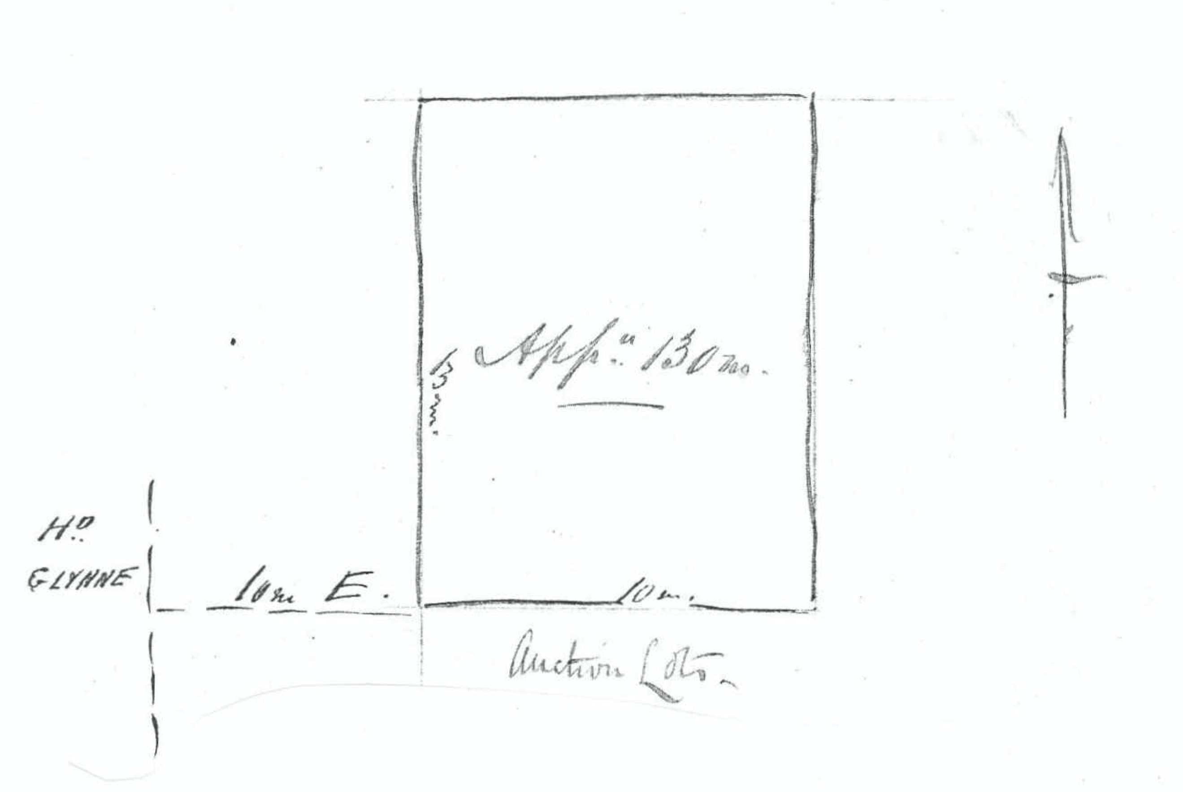

SCALE:— Four miles to one inch

I accept the above diagram as my act and deed.
F. J. H. von Mueller
by his agent F Krichauff

Annotation: 'Copy f[or Adelaide]'.
Spaces are left blank here and in several other places on the form.
Clause 4 of the regulations specified the way in which an application was to be made and 'except in cases where the land applied for is partially bounded by runs already leased, or where the natural feature of the country may render a regular outline impracticable, the land applied for shall be of rectangular form, the length of which shall not exceed twice its breadth, and one of the sides of which shall run as nearly as may be in a north and south direction'. Clause 2 of the regulations required the property to be stocked within three years 'at the rate of at least two head of great cattle [i.e., 'all manner of beasts except sheep and yearlings' (https://www.law-dictionary.org)] or ten head of small cattle, for every square mile of the country so applied for'. Other clauses regulated rental terms, forfeiture and the like ('Northern territory pastoral regulations', South Australian Government Gazette, 28 December 1876, pp. 2701-3.
Image courtesy of the National Archives of Australia. 78-01-30_image01.jpg In the original sketch the vertical lines are approximately 7 cm (slightly less than 3 in) long. Given the dimensions marked on it, the sketch therefore does not conform to the instruction concerning the scale to be used.

